H.T No
Regulations:
A15

Sreenidhi Institute of Science and Technology
(An Autonomous Institution)
Code No: 5U202 Date: 27-July-2018 (FN)

M.Tech I-Year II-Semester External Examination, July/Aug - 2018 (Supplementary)
CMOS ANALOG & MIXED SIGNAL DESIGN (VLSI & es)

Time: 3 Hours Max.Marks:75

Note: a) No additional answer sheets will be provided.
b) All sub-parts of a question must be answered at one place only, otherwise it will not be valued.
c) Missing data can be assumed suitably.

Part - A Max.Marks:25

Answer all QUESTIONS.

1. | Explain importance of sensitivity analysis in case of current mirrors. | [3M]
2. | Calculate gain and output resistance of source follower using current source load with neat sketch. | [3M]
3. | Define positive CMR, Negative CMR of Differential Amplifier and write equations related to them. | [3M]
4. | Draw the circuit diagram and mention the values of minimum and maximum common mode range of current source load N-channel Operational Transconductance Amplifier. | [3M]
5. | Implement Integrator using Switched Capacitor techniques. | [3M]
6. | What are the various specifications of DAC? Explain briefly. | [2M]
7. | Determine the current that flows in transistor M3 of figure shown. Neglect the oxide encroachment and the finite output resistance of M3.  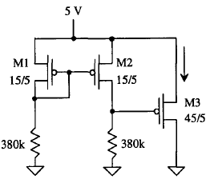 | [2M]
8. | Find the frequency response of the following Common Source amplifier.  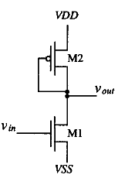 | [2M]
9. | Discuss typical errors associated with sample and hold circuit. | [2M]
10. | Define Slew Rate and Common Mode Range (CMR) of Operational Amplifier. | [2M]
Part – B Max.Marks:50
ANSWER ANY FIVE QUESTIONS. EACH QUESTION CARRIES 10 MARKS.

11. | a) | Explain the importance cascode current mirror over simple current mirror? Derive the output resistance of cascode current mirror. | [5M]
 | b) | Distinguish between Resistor MOSFET Divider and MOSFET only voltage divider with appropriate equations. | [5M]
12. | a) | For the circuit shown, Find (i) DC voltages and currents (ii) small signal gain and (iii) slew rate if the amplifier is driving a 10 pF capacitive load.  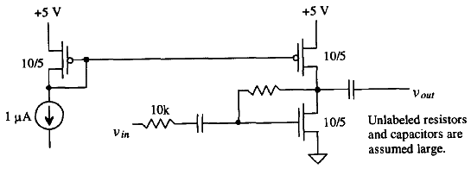 | [5M]
 | b) |  | [5M]
13. | a) | Explain how constant gain and stability is achieved in wide swing differential  amplifier. | [5M]
 | b) | Consider two sets of input voltages, where the first set of signals is v1 =+50 µv and v2 = -50 µv and the second set is v1 =+1,050 µv and v2 = 950 µv. If the CMRR is 100, calculate the difference in output voltage obtained for the two sets of input voltages | [5M]
14. | a) | Explain how a Operational Transconductance Amplifier (OTA) can be used to realize Low Pass filter and High Pass filter. | [5M]
 | b) | Design a Low Pass Filter using OTA for upper cutoff frequency of 1 MHz Assume Transconductance of OTA as 110 µA/volt. | [5M]
15. | a) | Explain how the comparator is characterized by DC performance and transient  response. | [5M]
 | b) | Design a switch capacitor filter with the transfer function, which has a pole at 500 Hz and a zero at 5 kHz. The low frequency gain of the circuit is 20 dB. Use a lossy integrator. | [5M]
 |  | Explain the following circuits :
16. | a) | The Pipeline ADC | [5M]
 | b) | Charge Scaling DAC | [5M]
17. |  | Explain the operation of threshold voltage referenced self biasing circuit. Specify the advantages and disadvantages. | [10M]

-- 00 -- 00 –

